
SHIRE HIGHLANDS EDUCATION DIVISION
2025 MALAWI SCHOOL CERTIFICATE OF EDUCATION MOCK
EXAMINATION

GEOGRAPHY
Subject Number: M073/II
Wednesday, 2st April, Time Allowed: 2 hours
1:00 - 3:00 pm

PAPER II
(50 Marks)
(Human Geography)

Instructions
Question number | Tick if answered | Do not write in these columns
1
2
3
4
5
- This paper contains 8 pages. Please check.

- The paper has two sections, A and B. Answer all the three questions in Section A and any other one question in Section B

- The maximum number of marks for each answer are indicated against each question.

- Write your name and school on top of each paper of the question paper

- In the table provided on this page tick against the question number you have answered.

- Hand in your question paper to the invigilator when time is called to stop writing

Turn over…../
SECTION A (75 marks)
Answer all the questions in this section in the space provided.
- a. Study Figure below showing a world map and answer questions that follow.
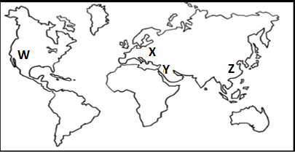
(i) Identify the farming systems practiced in regions marked W, X, Y and Z.
W ________________________________________________________________________
X ________________________________________________________________________
Y _________________________________________________________________________
Z _________________________________________________________________ 4 marks
(ii) Describe any two ways how high population influence farming at system in region Z.
_________________________________________________________________________________________________________________________________________________________________________________________________________________________________________________________________________________________________ 4 marks
b. (i) Explain any two economic factors that influence agriculture.
_____________________________________________________________________________________________________________________________________________________________________________________________________________________________________________________________________________________ 4 marks
(ii) Define the term plantation farming.
____________________________________________________________________________________________________________________________________1mark
(iii) Mention any one crop grown under plantation farming in Malawi.
_______________________________________________________________1 mark
(iv) Give any one district in Malawi where plantation agriculture is practised.
_______________________________________________________________1mark
(v) Mention any two ways in which plantation agriculture is important to the economy of Malawi.
___________________________________________________________________________________________________________________________________2 marks
c. Explain any two physical problems faced by Israel when practising irrigation.
_____________________________________________________________________________________________________________________________________________________________________________________________________________________________________________________________________________________________________4 marks
d.(i) Explain any one physical factor that favour dairying in Denmark.
______________________________________________________________________________________________________________________________________________2 marks
(ii) List down ant two dairy products from daily farming.
______________________________________________________________________________________________________________________________________________2 marks

- a. (i) Define the term industrialisation.
______________________________________________________________________________________________________________________________________________1 mark
(ii) State any two types of industries.
______________________________________________________________________________________________________________________________________________2 marks
(iii) Explain any two factors for the industrialisation of Western Europe
__________________________________________________________________________________________________________________________________________________________________________________________________________________________________________________________________________________________________4 marks
b. Explain any two strategies for the management of wetlands.
_________________________________________________________________________________________________________________________________________________________________________________________________________________________________________________________________________________________________4 marks
c. (i) Explain any two human factors that influence fishing.
_________________________________________________________________________________________________________________________________________________________________________________________________________________________________________________________________________________________________4 marks
(ii). Explain any two problems faced by the fishing industry.
__________________________________________________________________________________________________________________________________________________________________________________________________________________________________________________________________________________________________4 marks
(iii). Draw map of North America. On the map shade and name any one fishing ground.

4 marks
d. Give any two ways in which waste management is important.
______________________________________________________________________________________________________________________________________________2 marks

- a. Study Figure below showing a diagram of oil extraction. Use it to answer questions that
follow.
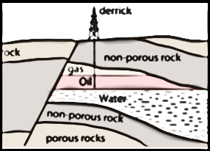
(i) What type of mining is taking place in the figure above?
____________________________________________________________________1 mark
(ii). Identify the type of oil trap shown in the diagram above. _____________________________________________________________________1 mark
(iii) Explain the process of oil extraction taking place in the figure above.
_________________________________________________________________________________________________________________________________________________________________________________________________________________________________________________________________________________________________________________________________________________________________________________________________________________________________________________________________5 marks

(iv) Give any two negative effects of oil extraction on the environment.
______________________________________________________________________________________________________________________________________________2 marks
b. Give any two member nations of the Organization of Petroleum Exporting Countries in
Africa.
______________________________________________________________________________________________________________________________________________2 marks
c. (i) With the aid of a well-labelled diagram describe how hydro-electrical power is generated.

______________________________________________________________________________________________________________________________________________________________________________________________________________________________________________________________________________________________________________________________________________________________________________________________________________________________________________________6 marks
(ii) List down any two advantages of solar power.
______________________________________________________________________________________________________________________________________________2 marks
d. (i) Explain any two positive effects of energy crisis in Malawi.
__________________________________________________________________________________________________________________________________________________________________________________________________________________________________________________________________________________________________4 marks
(ii) Why does Malawi not venture into nuclear energy production?
______________________________________________________________________________________________________________________________________________2 marks

Section B: (25 marks)
Answer only one question from this section.
- a. Study Figure below showing a map of Africa and answer questions that follow.
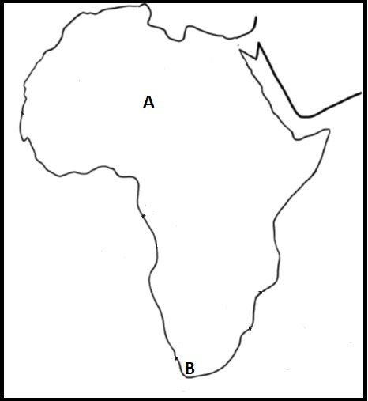
(i) Which letter, represents each of the following
1. Densely populated.
________________________________________________________________1 mark
2. Sparsely populated
_______________________________________________________________1 mark
(ii) Describe any two factors for the population density at A.
_________________________________________________________________________________________________________________________________________________________________________________________________________________________________________________________________________________________ 4 marks
(iii) Give any two negative effects of rapid population growth on development.
_________________________________________________________________________________________________________________________________________2 marks
b. (i) Draw a graph showing comparative transport costs for road, rail and water transport.

3 marks
(ii) Describe the graph that you have drawn in 4.b (i) above.
__________________________________________________________________________________________________________________________________________________________________________________________________________________________________________________________________________________________________________________________________________________________________________________________________________________________________________________________________________________________________________ 6 marks
c. Explain any two ways of reducing rural-urban migration.
_____________________________________________________________________________________________________________________________________________________________________________________________________________________________________________________________________________________________________4marks
d. Describe any two advantages of the Suez Canal over Panama Canal.
_____________________________________________________________________________________________________________________________________________________________________________________________________________________________________________________________________________________________________4 marks
- Study Figure below showing population structures of Country A and Country B and answer questions that follow.
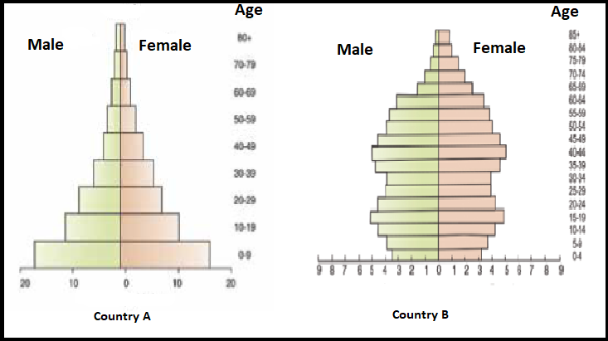
a. (i) Why does Country A have a wide base?
__________________________________________________________________________________________________________________________________________1 mark
(ii) Explain why Country B has a narrow base.
__________________________________________________________________________________________________________________________________________1 mark
(iii) Between the two countries, A and B, which one has a low dependency ratio?
__________________________________________________________________ 1 mark
(iv) Give a reason for your answer 5.a.(iii).
_________________________________________________________________________________________________________________________________________2 marks
(v) Explain the economic implication for Country A with such population structure?
________________________________________________________________________________________________________________________________________2marks
b. Describe two points on the following stages of the demographic transitional model:
1. Stage two or Early expansion stage
_________________________________________________________________________________________________________________________________________2 marks
2. Stage four or Low stationary stage
_________________________________________________________________________________________________________________________________________2 marks
c. Give any two aims of COMESA.
_________________________________________________________________________________________________________________________________________________________________________________________________________________________________________________________________________________________________________4 marks
d. (i) List down any two wildlife reserves along the Shire River.
_________________________________________________________________________________________________________________________________________2 marks
(ii) Describe any two human activity that endanger wildlife in Malawi.
_________________________________________________________________________________________________________________________________________________________________________________________________________________________________________________________________________________________4 marks
(iii) Explain any two measures of conserving wild life species.
_________________________________________________________________________________________________________________________________________________________________________________________________________________________________________________________________________________________4 marks
END OF QUESTION PAPER
NB: This paper contains 8 printed pages

